Title or Task: | Multimedia  
Description: | TASK 2: Web Page on Gizmo’s

Files Required
Suitable for Classes: | Multimedia / Digital Media or Design
Area: | Technology & Enterprise
Teacher: | Mr Peter Faulks
Marks: | Worth: 20% | Weighting: 20%
Date Due: | Late penalty 5 marks plus 2 marks per day thereafter

Task Brief:
Outcomes: | Investigation : Devising : Producing : Evaluating

Items highlighted in yellow are tasks for you to complete
Items in Purple are help tips
Task
2
UNIT: Multimedia
TASK 2: Web Page on Gizmo’s (100 marks)
Explanation

Time allocation 2 weeks

What you need to do: Complete the worksheet
DMX 100 Dreamweaver Setting your site.doc

Investigate what makes a good web page, identify your target audience, create a journal starting today and a time plan showing when you hope to complete the pages, buttons, animations etc.

Get information From the Internet i.e.

NOTES: A portable multimedia player (PMP), sometimes referred to as a portable video player (PVP), is a consumer electronics device that is capable of storing and playing digital media. Digital audio players (DAP) that can also display images and play videos are PMPs. Like DAPs, the data is typically stored on a hard drive, micro drive, or flash memory. Other types of electronic devices like mobile (usa = cell) phones are sometimes referred as PMPs due to their playback
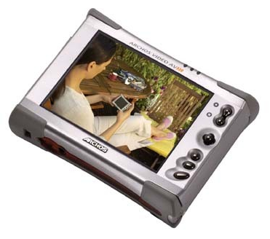

Get images From the Internet i.e. Archos Personal Video Player
Link : www.trustedreviews.com
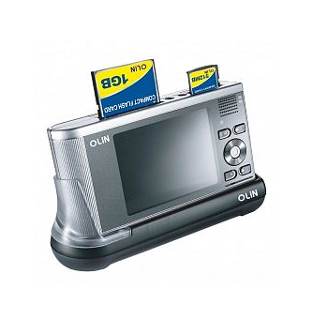
Your task is to create a simple linear web page about a gizmo multimedia device such as:
- Mobile Phone
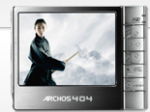
- MP3 player with music plus movie/video playback
- DVD Player with Image and music capability
- Blackberry
- Bluray or DVD Recorder
- Portable entertainment system,
- LCD, LED or Plasma TV
- Surround sound system etc.
- Your choice

To Do | Submitted
- Use the web planning sheet to plan your site draw up where you feel buttons will be placed and explain what your site is about.
- Page 1 Create a web page with your name on the first page, your product (Welcome Page known as a SPLASH page) (saved as index.html) plus add links to at least two more pages. Discuss the advantages of DIGITAL CONVERGENCE on this page.
- Page 2 will contain how to use your product.
- Page 3 will contain information comparing your product to similar devices
- You may include costs, comparison with other products or additional information that you feel relevant.
- Include one animated logo or element on your welcome page.
- Include rollover buttons to link pages
- Complete the evaluation form

What needs to be in your portfolio for assessment?
- Evidence of your investigation (notes, bibliography, brainstorm
- Your detailed report which is one document containing:
- cover page
- table of contents
- header/footer
- page numbers
- graphics inserted
- clear use of font
- neatly formatted.
- Your report must demonstrate research, show depth and explore options by covering the following content in detail:
- technical specification for replacement hardware/software with prices and reasons behind the selected specification.
- a replacement timeline for future upgrades.
- cost of implementing your suggested hardware.
- a suggested method of replacement so that the business has the least down time.
- what infrastructure they should have in place.
- what physical and logical security issues they should cover.

Web Page Planner

Page 1 = Welcome
Page 2 = A multimedia Entertainment unit
SPLASH PAGE
(index.html)

Welcome to my Gizmo Web Page

YOUR NAME

Contact me
Digital Convergence
MULTIMEDIA PACKAGE
Samples of item
Other
how it works where you buy it etc.
Other page if required

You must put information on how to use the player and how it compares to others
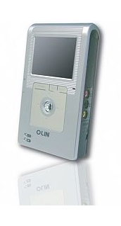

Link the pages with buttons and ensure you can link back to your home page and across to other buttons.

Extra marks:
You can add an animated logo or demo of your product.
Use of creative buttons
Use of creative text as headers
Use of links

MARKING KEY GIZMO

Task 5: creation of an advertisement, how to web page Total: 100

Item | Possible  Mark | Actual Mark
Planning | 25
Investigate what makes a good web page | 5
Why type of product selected | 5
Audience identified | 5
Timeline/project plan | 5
Distribution options | 5
Product (Web Design Sheet) | 45
Draft design | 5
Story boards | 5
Supporting arguments/principles | 5
Proposal | 5
Rollover Buttons | 10
Plan | 5
Animated Logo or Element | 5
Hardware and software needed | 5
Evaluation | 30
Project evaluation | 10
What were you asked to do? | 5
What you did do? | 5
What would you do better? | 5
Journal | 5
Total | 100

Teacher Comment:

Self-Evaluation Form Web Page Gizmo

You have recently been working on a task.
Your next part is to honestly evaluate your own performance, your peers performance and your overall group performance. This evaluation will assist in the determination of some of the course outcomes. It is a confidential evaluation and only Mr Faulks will read it.

Task: __________________________________ Task Number:___________

Your Name: __________________________________ Date:____________

List down all the tasks that you have completed during the investigation of your task

Devising
How did you plan your design – Storyboard, Brainstorm, Notes, Sketches, Just did it, other?
What did you do?
How did you do it?
Why

Investigating
What did you read or look up?
What did you do?
How did you do it?
Why

Producing
What software did you use? Did you use graphics, boxes, objects, clip art?
What did you do?
How did you do it?
Why

Evaluating
Have you completed this evaluation form and rated yourself? Yes/No
Product evaluation, I could improve my final product by:

List down any of the new skills you have learnt while investigation of your task
Answer:

What are some things you have found out about yourself while investigation of your task (eg – I didn’t know I had such good leadership qualities, I always need someone to keep me on task)
Answer:

Reflect on the process that you have gone through since commencing your investigation of your task, write about any successes or problems you have personally encountered. (focus on yourself only).
Answer:

Do you consider yourself to be a consistent worker (eg will be on task for most of the week). Answer:
Why? Why Not? Give examples where appropriate.

Do you think your application to the task has improved your planning skills?
Answer: Why? Why Not? Give examples where appropriate

Rate yourself on the following criteria
(6 outstanding, 5 very good, 4 satisfactory 3 not demonstrated)

Ability to locate information & research without any assistance
Shows initiative
Leadership Qualities
Application to the task
Time Management
Works without any ‘nagging’ from the teacher

Did you personally enjoy investigation of your task? Yes / No

What are some things you liked about this task?
Answer:

What are some things you disliked about this task?
Answer:

The course requires you to think a lot for yourself and to find out your own information, did you find this type of environment an enjoyable one to work in, or do you prefer the teacher up the front of the class teaching the information and then getting tested on it?

Please comment. Answer:

Evaluation Individual Task

Task Number

Your Name Date

Tick the appropriate box: | No | Undecided | Yes
I found this task interesting
I have worked hard on this task
I have understood the task requirements
I enjoyed working on the task
I had enough time to complete the task
I had all the skills required to complete the task
I am happy with my finished product
I found it easy to find the information I required

My favourite part of the task was:

The most difficult part of the task was

The easiest part of the task was:

The most interesting part of the task was:

I could improve my final product by:

Additional Comment:

